1. What is File Allocation?
When a file is saved to disk, it rarely fits perfectly into one contiguous block. The disk is divided into fixed-size units called clusters (or blocks), and the file system needs a strategy to decide:
- Which clusters a file occupies
- How to find the next cluster when reading the file
- How to mark clusters as free when a file is deleted
This strategy is called the file allocation method.
2. Why It Matters :
- It determines how fast files can be read/written
- It determines how much space is wasted (internal fragmentation)
- It determines what's recoverable after deletion.
3. The Three Classic Allocation Methods
A. Contiguous Allocation
- File is stored in one continuous block of clusters.
- Directory entry just needs: starting cluster + length.
- ✅ Fast access (sequential + direct)
- ❌ Fragmentation over time; hard to grow a file if space after it is taken
B. Linked Allocation
- File is stored as clusters scattered across the disk, each cluster holding a pointer to the next.
- Directory entry needs only the starting cluster.
- ✅ No external fragmentation, files can grow easily
- ❌ Slow random access (must follow the chain); pointer overhead; a broken link can lose the rest of the file (forensically important — this is why recovery is harder on fragmented files)
C. Indexed Allocation
- A separate index block stores all the cluster addresses for a file.
- ✅ Fast direct access, no chain-following
- ❌ Extra space needed for the index block itself
4. How Real File Systems Implement This
FAT32 (Linked-style via table)
- Uses the File Allocation Table (FAT) — essentially a big linked list stored separately from the data.
- Each entry in the FAT corresponds to a cluster and points to the next cluster in the file's chain (or marks End-Of-File).
- Directory entry stores only the starting cluster number.
- Two copies of the FAT are kept for redundancy (this ties into $MFTMirr-type resilience concepts you can contrast with NTFS).
- Forensic note: if a file is deleted, its directory entry is marked free but the FAT chain and data often remain — this is exactly why recovery tools like Autopsy can reconstruct it.
NTFS (Indexed-style via MFT)
- Uses the Master File Table (MFT) — every file/folder gets an MFT record containing metadata and, for small files, the data itself (resident files).
- For larger files, the MFT record stores data runs — essentially an index of cluster ranges (start cluster + length), which is far more efficient than a long linked chain.
- This is why NTFS handles fragmentation and large files better than FAT32.
EXT (Linux family)
- EXT2/3 used direct + indirect + double-indirect block pointers per inode (a tiered indexed approach).
- EXT4 improved this using extents — a range-based addressing method similar in spirit to NTFS data runs, replacing block-by-block pointers with "start block + length" for large contiguous chunks.
3.4 Metadata and Timestamp Analysis:
1. What is Metadata?
Metadata is data about data — it describes a file without being the file's actual content. You never need to open a file to read its metadata.
Bridge line for class:
"If the file content is the letter itself, metadata is everything written on the envelope — sender, date, size, handling stamps."
2. Categories of File Metadata
A. File System Metadata (stored by the OS/file system itself)
- File name and extension
- File size
- Timestamps (Created, Modified, Accessed)
- Attributes (Hidden, System, Read-only, Archive)
- Starting cluster/sector location
- Permissions/ownership (NTFS ACLs, Linux inode permissions)
B. Embedded/Application Metadata (stored inside the file by the software that created it)
- Word docs: Author, "Last saved by," edit time, revision number, company name
- Images (EXIF data): Camera model, GPS coordinates, date taken, software used to edit
- PDFs: Creator application, producer, creation/modification date
This distinction matters forensically — file system metadata can be spoofed by changing system clock or using timestamp-editing tools, but embedded metadata often survives copying and can contradict the file system's story (e.g., EXIF says photo taken in 2023, but file system says created 2026 — sign of tampering or transfer).
3. MAC Times — The Core of Timestamp Analysis:
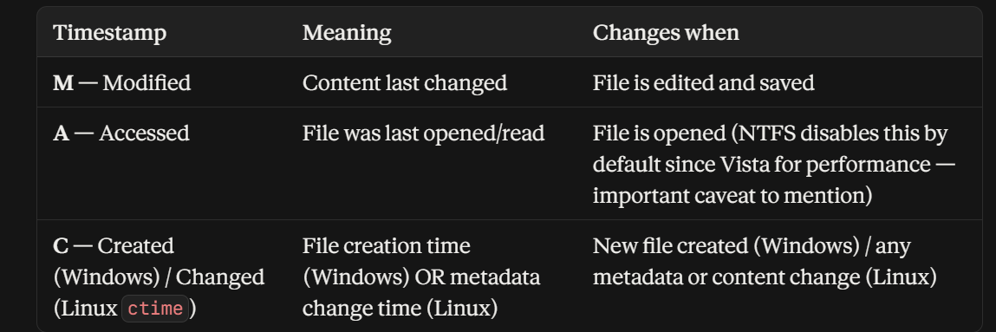

4. Why Timestamps Matter Forensically
- Building a timeline of events — what happened, in what order, around an incident
- Detecting tampering — e.g., Modified date earlier than Created date is a red flag (classic sign of timestamp manipulation, sometimes called "timestomping")
- Correlating evidence across multiple files/systems to establish a sequence (e.g., malware dropped → executed → logs modified)
- Establishing user activity — Accessed times can show if/when a suspect opened a file (when not disabled)
5. NTFS vs FAT32 Timestamp Precision (good comparison point)
- FAT32: Creation time accurate to 10ms, but Modified time only accurate to 2 seconds, and Accessed time stores only the date (no time at all)
- NTFS: All timestamps accurate to 100-nanosecond intervals, stored in UTC and converted for display — more forensically reliable
6. NTFS Has Two Sets of Timestamps (advanced point, great for a "did you know")
Every NTFS file actually has two timestamp sets:
- One in the $STANDARD_INFORMATION attribute (what Explorer/dir shows you)
- One in the $FILE_NAME attribute (harder to alter, often ignored by casual anti-forensic tools)
If these two sets disagree, it's strong evidence of timestamp manipulation — a widely used forensic detection technique. Worth a slide of its own if you have time.

